Chapter 11, Solution 26.

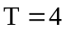, 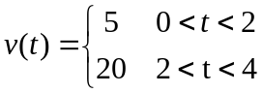

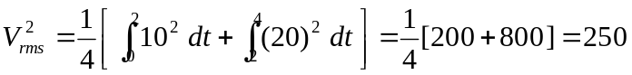

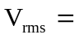15.811 V.

